

**Assignment # 1**

**Digital Image Processing**

**LAB**

**Submitted To: Dr. Noman Islam**

**Submitted By: Muhammad Abdulrehman siddiqui (10593)**

Date: 28th April 2018

***NUMPY ASSIGNMENT***

***Numpy #01***

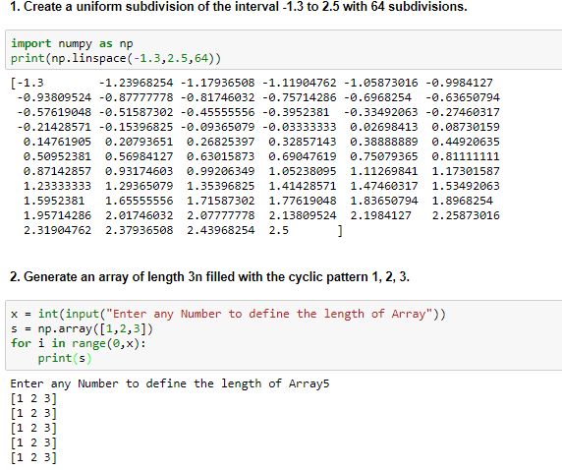

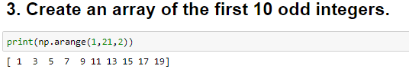

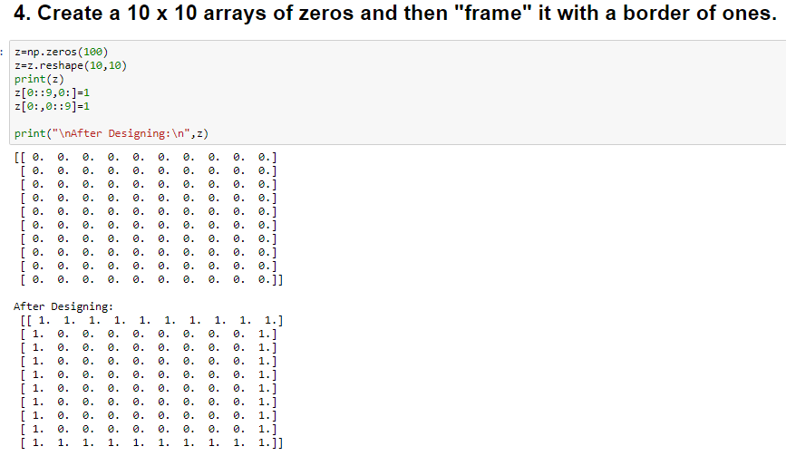

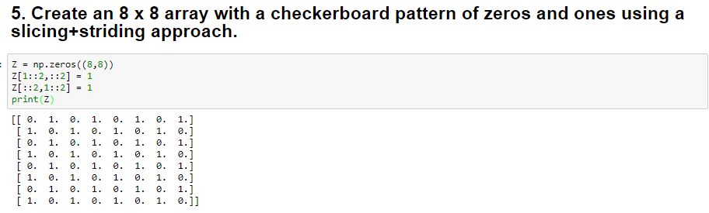

***Numpy #02***

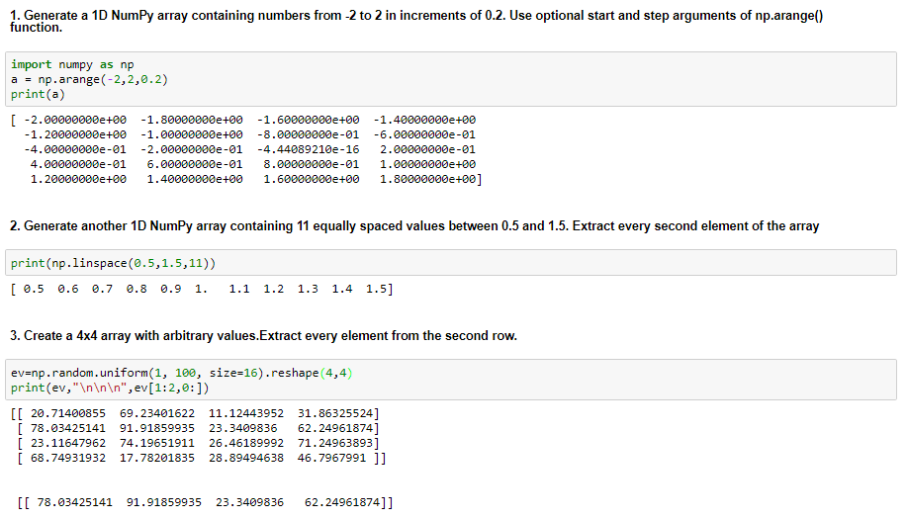

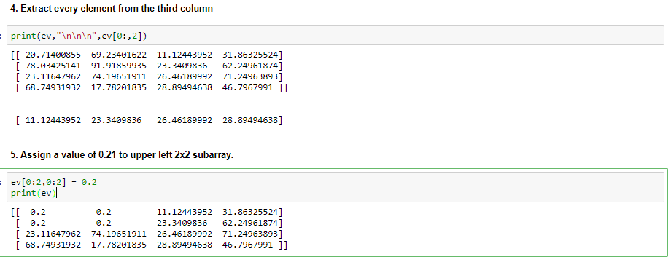

***Numpy #03***

